Modelling study of CO₂ sequestration by mineral waste carbonation process
Natalia Vidal de la Peñaª, Dominique Toyeª, Grégoire Léonardª,
ªChemical Engineering, University of Liège, B6a Sart-Tilman, 4000 Liège, Belgium nvidal@uliege.be
Abstract
The objective of this work is to develop a COMSOL Multiphysics numerical model to represent the physico-chemical phenomena associated to CO₂ sequestration by mineral waste carbonation process. In the model, the bed of particles is described as a dual-scale porosity medium. The two scales considered are the intragranular and intergranular scales. The model is formulated to predict phenomena occurring in the dual-scale system, considering the diffusion of CO₂ between particles and within them. This involves the characterization of crucial parameters such as the porosity and the amount of water present both inside and outside the solid particles. The proposed model is qualitatively validated against existing literature and quantitatively validated against experimental results. This article presents the results obtained for the Ca(OH)₂ carbonation during three days, emphasizing the significance of the COMSOL software in comprehending the process thoroughly.
Keywords: Mineral carbonation, multi-scale modelling, CO₂ capture, CO₂ sequestration
  - Introduction
Nowadays, the continuous pursuit of human well-being and the improvement of quality-of-life lead to the increasingly high consumption of natural resources, reaching depletion and generating waste and pollutants that are difficult to manage. This is evident in the construction industry, as it is one of the main contributors to CO₂ emissions, producing around 10 Gt of CO₂ in 2022, as presented by the United Nations Environment Program (2022). In addition to CO₂, this industry significantly contributes to waste streams, accounting for 37.5% of the total European waste in 2020, as reported by Eurostat (2020). Taking in consideration the increasing trend of the presence of CO₂ in the atmosphere, the EU established a Green Deal to achieve carbon neutrality by 2050 and a reduction of 55% in the CO₂ concentration by 2030. To this end, the EU is focusing on improving energy efficiency, renewable energy and the CCUS (Carbon Capture, Utilization and Storage) technologies. Regarding this goal, it is necessary to find solutions that can help the reduction of emissions in the construction sector.
As a response to this situation, the capture of CO₂ is proposed through the carbonation of hydrated lime, the symbol of which is “Ca(OH)₂” in the chemical engineering sector and “CH” in the construction one. The hydrated lime has been chosen due to its presence in the recycled concrete aggregates (RCA) which are nowadays getting more importance to mitigate the consumption of natural resources of the concrete industry (Vidal de la Peña et al., 2023). In this case, the residues are collected, treated and then, carbonated so the carbonation of construction waste is made ex-situ. The amount of carbonatable components will define the carbonation potential of the material. In case of need, the efficiency of the reaction can be increased by applying some pre-treatments to the material, such as the decreasing of the particle size distribution or the optimization of the relative humidity in the system. During this process, the highest energy consumption phases are the obtention of the carbonatable material by separation processes, if needed, and the preparation of the material by crushing, among others (Vidal de la Peña et al., 2023).
Ex-situ mineral carbonation can be conducted both directly and indirectly. This article focuses on the gas-solid direct carbonation which consists of the reaction between carbonatable materials with CO₂ in a single stage, avoiding the several stages in the indirect carbonation processes (Vidal de la Peña et al., 2023). As the process allows the simultaneous recycling and valorization of two waste streams, i.e., CO₂ and Ca(OH)₂, it is of direct interest for the construction sector to strengthen its contribution to a more sustainable circular economy. In this work, a COMSOL Multiphysics numerical model is proposed to explain and optimize a direct carbonation process of construction materials and wastes.
  - Mathematical description of the model
The carbonation process has been simulated in a 2D axisymmetric cylindrical reactor (length = 70 mm – diameter 70 mm), filled with spherical Ca(OH)₂ particles with 1 mm of particle diameter, arranged in linear rows configuration (Figure 1a). On the reactor conceptual design implemented in COMSOL (Figure 1b), CO₂ is introduced into the reactor from the bottom (x=0), with the maximum concentration of CO₂ at the reactor inlet.
Besides this bottom entry flux, the flux conditions on the other boundaries are “no flux”. The reactor top side and lateral wall (right side of the scheme) are hermetic, so there is no outgoing CO₂ flux. The left boundary on the scheme corresponds to the central axis of the cylindrical bed, where the symmetry condition imposes a null flux. Furthermore, the initial concentration of CO₂ at the bottom of the reactor is 4 mol/m³ during the whole process, equivalent to a 10% of molar-volume fraction. The initial conditions in the reactor are uniform: zero concentration of CO₂. The Ca(OH)₂ concentration in the particles equals to 4000 mol/m³, which leads to Ca(OH)₂ concentration of 2400 mol/m³ at the reactor scale if the bed porosity ($ϕ_{bed}$ = 0.4) is considered.
Carbonation is a complex process that takes place in a heterogeneous (gas-solid) system with two levels of porosity, the results of which depend not only on the chemical reaction between Ca(OH)₂ and CO₂, but also on the coupling of this reaction with various physical and chemical phenomena occurring at different scales.

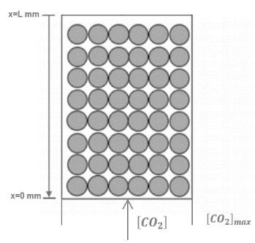
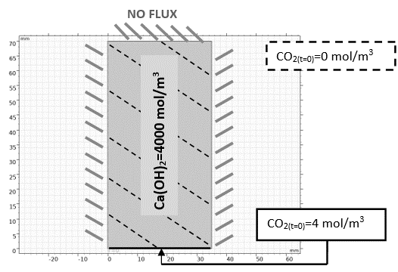
Figure 1: a. Scheme of the principle of the granular bed configuration. b. Axisymmetric reactor and conditions modelled in COMSOL.
Basically, the system is described by the following parameters: the porosity of the bed, which is defined by the bulk density of the material and the particle density, the particle porosity that is calculated by the bulk density and the porous volume, the water content present along the granular bed and the water content present in the particles. These parameters influence diffusion phenomena both along the bed and inside the particles. Higher porosity (both bed and particle) will enhance the diffusion phenomenon, while higher water content (both in the bed and in the particles) will worsen the diffusion process. In contrast to the diffusion process, chemical reactions occur only inside the solid particles, and they are influenced by the water-to-solid mass ratio inside them. The chemical reaction considered in this model is represented by the following equation, the rate of which is determined using a second-order mass action law.
$$Ca{(OH)}_{2}(s) + {CO}_{2}(g)=>{CaCO}_{3}(s)+H_{2}O(l)$$ | (1)
From the reaction, water is released, being a critical aspect due to its substantial impact on the system. Initially, the material must contain a minimum amount of water to initiate the carbonation reaction; without sufficient humidity, no reaction occurs.
On the contrary, an excess of water in the system can lead to material agglomerations, pore clogging, impeding the entry of CO₂ and thereby reducing system efficiency. The quantity of water significantly influences both the reaction kinetics and the diffusion of CO₂ inside the particles and into the granular bed, i.e., between the particles. Given its significance, characterizing this parameter is crucial. So, its influence is incorporated into the calculation of the kinetic constant in our model as well as in the diffusion coefficient($D_{p}$) in the particles. Therefore, the influence of water quantity is introduced in the rate law as expressed in the following equation.
$$R=k_{0}∙\left[CO_{2}\right]∙\left[Ca({OH)}_{2}\right]∙sl$$ | (2)
Where $k_{0}$ represents the kinetic constant with a value equal to 0.00025 mol/m³s (L.Reich et al., 2014), $\left[CO_{2}\right]$ denotes the concentration of carbon dioxide in mol/m³, $\left[Ca({OH)}_{2}\right]$ is the concentration of Ca(OH)₂ in mol/m³, and $sl$ is the water-to-solid mass ratio in the particle. As mentioned earlier, this parameter promotes the reaction as it is necessary to initiate it, but its effect becomes negative after reaching a certain maximum value. To incorporate this influence into the reaction rate, specific conditions have been imposed. If $sl$ is less than 0.05, its value is corrected to 0. If it is between 0.05 and 0.9, it is taken as it is. And if $sl$ is equal or greater than 0.9, its value is equal to 1. In this work, the initial value of $sl$ considered is 0.1.
The diffusion of CO₂ in the granular bed (between particles) will be affected by the bed porosity ($ϕ_{bed}$) and by the bed water-to-solid mass ratio ($S_{l}$). The equation to determine the bed diffusion ($D$) is based on the Belin et al.(2013) work and is described as follows.
$$D=D_{{CO}_{2}}^{0}∙{ϕ_{bed}}^{4/3}∙{\left(1-S_{l}\right)}^{10/3}$$ | (3)
Where $D_{{CO}_{2}}^{0}$ is the specific diffusion coefficient of CO₂ at a pressure of 0.1 MPa and a temperature of 273 K, with a value of 1.6E-5 m²·s⁻¹. The correction term used to account for porosity and water content effects is calculated using the Millington’s correlation equation (Belin et al., 2013). The bed porosity $ϕ_{bed}$ is taken equal to 0.4 and remains constant. The water saturation around the particles, $S_{l}$, is assumed to be zero, as the presence of a water film around the particles can be neglected due to their small size (less than 1 mm) (Belin et al., 2013).
On the other hand, the diffusion coefficient inside the particles is calculated as follows.
$$D_{p}=D_{{CO}_{2}}^{0}∙{Φ_{p}}^{2.7}∙{\left(1-sl\right)}^{4.2}$$ | (4)
The correction factor for porosity and water content is calculated using the expression of Thiery (2005). $Φ_{p}$ represents the particle porosity. $sl$ denotes the water-to-solid mass ratio. As the carbonation process progresses, the Ca(OH)₂ is progressively converted to CaCO₃, the molar volume of which (calculated as $\frac{{MM}_{i}}{ρ_{i}}$) is larger. If a constant total solid volume is considered, the carbonation process leads to a reduction of particle porosity. The porosity evolution may be related to the degree of carbonation of the particles ($η_{p}$), using the following expression.
$$Φ_{p}\left(t\right)=Φ_{p_{,t=0}}∙\left[\left(1-η_{p}\right)+η_{p}∙\frac{{MM}_{C{a\left(OH\right)}_{2}}}{{MM}_{C{aCO}_{3}}}∙\frac{ρ_{C{aCO}_{3}}}{ρ_{C{a\left(OH\right)}_{2}}}\right]$$ | (5)
Where $Φ_{p_{t=0}}$ is the initial porosity of the particles, ${MM}_{C{a\left(OH\right)}_{2}}$ and ${MM}_{C{aCO}_{3}}$ are the molar masses of Ca(OH)₂ and CaCO₃ equal to 74 g/mol and 100 g/mol, respectively, $ρ_{C{aCO}_{3}}$ and $ρ_{C{a\left(OH\right)}_{2}}$ are the densities of Ca(OH)₂ and CaCO₃, equal to 2.21 g/cm³ and 2.71 g/cm³. $η_{p}$ is the degree of carbonation of the particles, calculated as follows.
$$η_{p}=\frac{{\left[CaCO_{3}\right]}_{p}}{{\left[{Ca(OH)}_{2}\right]}_{p,t=0}}$$ | (6)
A complete carbonation ($η_{p}$=1) corresponds to a 10% relative variation in porosity. As computed in equation (6), $η_{p}$ compares the molar concentration of CaCO₃ inside particles ${(\left[CaCO_{3}\right]}_{p}$) to the maximum concentration of CaCO₃ that can theoretically be reached, equal to the initial molar concentration of Ca(OH)₂ inside particles, ${\left[{Ca(OH)}_{2}\right]}_{p,t=0}$. $η_{p}$ values were computed from concentration profiles simulated in COMSOL. They were then compared to experimental data.
  - Results and discussion
After introducing the equations and correlations in the model, concentration profiles were simulated for different reaction times. The temperature and pressure were kept constant at 273 K and atmospheric pressure. The objective was to get a better understanding of the carbonation process as a whole and to analyze how the particle porosity and water-to-solid mass ratio evolve and impact the process.

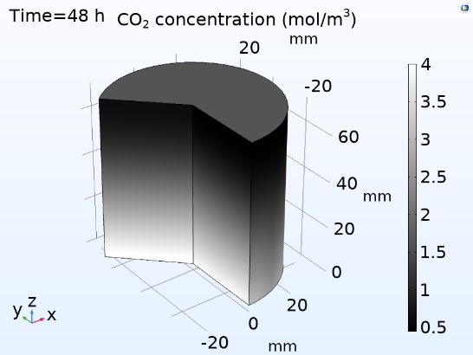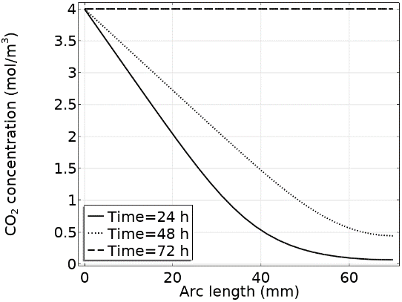
Figure 2: a. CO₂ gradient concentration along the 3D reactor. b. CO₂ concentration along the reactor after 24 h, 48 h and 72 h of carbonation.
Figure 2a shows the 3D distribution of CO₂ concentration in the reactor after 48 h. Figure 2b presents the CO₂ concentration vertical profiles along the granular bed (from bottom to top) at different times. Figure 2a shows that CO₂ enters at the bottom of the reactor and penetrates gradually. After 48 hours, the reactor is not yet filled with CO₂. Figure 2b shows the CO₂ concentration in different reactor cross-sections after one, two and three days. Interestingly, after 72 hours, the reactor is completely filled with CO₂.
Complementary to Figure 2, Figure 3 shows the CaCO₃ concentration distribution in the reactor. As above, Figure 3a shows the 3D distribution at a given time (48 hours) and Figure 3b the 2D vertical profiles at different times (24, 48, and 72 hours). Logically, the bottom of the reactor exhibits a higher concentration of carbonated material compared to the top. These results confirm those presented in Figure 2.
Regarding the maximal concentration of CaCO₃ at the bed scale, it logically equals the initial bed scale concentration of Ca(OH)₂ equal to 2400 mol/m³. If these concentrations are related to the solid particle volume, one obtains 4000 mol/m³ solid for both. After 72 h, the carbonation process is completed: the maximal carbonate calcium concentration is achieved in all the reactor and the latter is filled with CO₂ in excess.
The evolution of the water-to-solid mass ratio and of the particle porosity throughout the carbonation process are also accounted for in the model. The initial value of the water-to-solid mass ratio considered is equal to 0.1 and the initial particle porosity is 0.49.

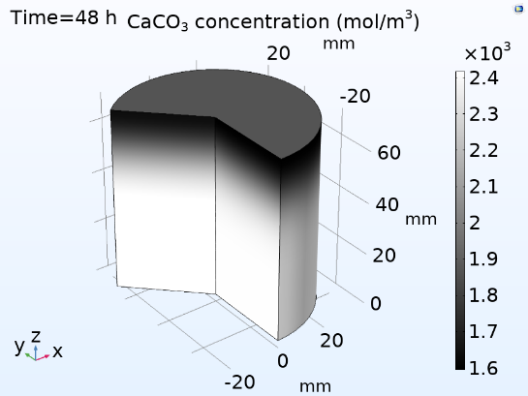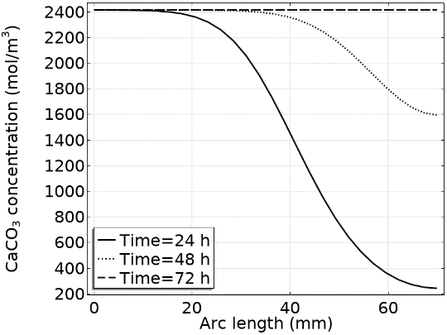
Figure 3: a. CaCO₃ gradient concentration along the 3D reactor. b. CaCO₃ concentration along the reactor after 24 h, 48 h and 72 h of carbonation.
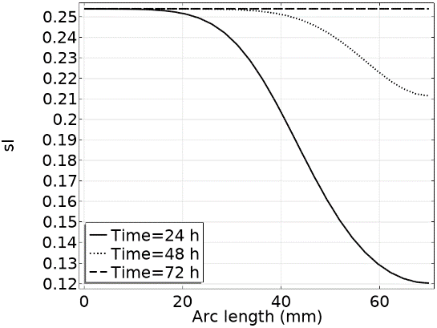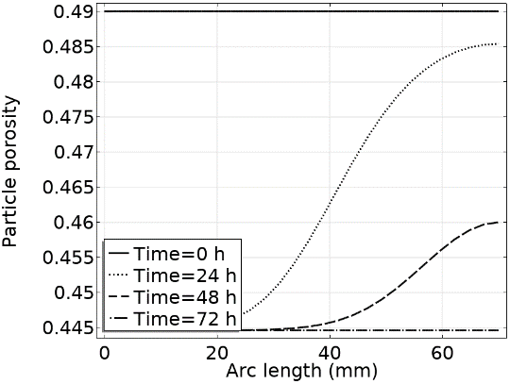
Figure 4: a. Water-to-solid mass ratio variation along the reactor during the carbonation process. b. Particle porosity variation along the reactor during the carbonation process

Figures 4a and 4b show the evolution, during the carbonation process, of the water-to-solid ratio ($sl$) and of the particle porosity ($Φ_{p}$) profiles, respectively. Concerning the water content, Figure 4a shows that it increases at the same time as Ca(OH)₂ is consumed and CaCO₃ is produced (Figures 2 and 3), due to the generation of H₂O by the carbonation reaction. This parameter reaches a maximum value of 0.25.
Concerning the particle porosity, Figure 4b shows that it decreases as the solid is carbonated. The porosity decreases from 49% to 44.5%, which corresponds to the 10% relative variation predicted by Equation (5). The model enables the observation of how this parameter varies across different layers of the reactor, reaching its minimum value throughout the entire reactor after 3 days of carbonation.
Finally, these simulation results were compared with experimental results obtained by the company Centre Terre et Pierre (CTP) within the framework of the Mineral Loop project financed by the Walloon Region. The agreement is quite satisfying as the gap between simulations and experiments is smaller than 20%, if one uses the total mass carbon ratio as comparison criterion.
  - Conclusions
In conclusion, this study facilitates a comprehensive understanding of the carbonation process and contributes to its optimisation by providing the capacity to analyse the influence of various parameters. These parameters include particle and bed porosities and particle and bed water-to-solid mass ratios, all of them playing a crucial role in the carbonation process. The developed model significantly contributes to advancements in CO₂ capture technologies and supports investments in the circular economy. By utilizing hydrated lime for capturing CO₂ within the same sector, the model enables the production of calcium carbonate, which can subsequently be utilized as an aggregate in construction materials. This mathematical model aligns with the goals of sustainability and circular resource utilization in the field.
Acknowledgements
This research has been financed by the Walloon Region Mineral Loop project.
References
Eurostat, Waste Statistics for EU. <https://ec.europa.eu/eurostat/statisticsexplained/index.php?title=Waste_statistics#Hazardous_waste_generation>, (accessed 1/12/2023).
L. Reich, L. Yue, R. Bader, and W. Lipiński, 2014, Towards Solar Thermochemical Carbon Dioxide Capture via Calcium Oxide Looping: A Review, Aerosol Air Qual, Volume 4, Issue 2, pages 500-514.
M. Thiery, Modelling of atmospheric carbonation of cement based materials considering the kinetic effects and modifications of the microstructure and the hydric state,2005, Engineering Sciences [physics], Ecole des Ponts ParisTech
N. Vidal de le Peña, S. Grigolleto, D.Toye, L.Courard, G.Léonard, 2023, CO₂ Capture by mineral carbonation of construction and industrial wastes, Circular Economy Processes for CO₂ Capture and Utilization: Strategies and case studies, Pages 163-185
P. Belin, G. Habert, N. Rousse, M. Thiery, P. Dangla, 2013, Carbonation kinetics of a bed of recycled concrete aggregates: a laboratory study on model materials, Cement and Concrete Research,Volume 46, Pages 50-65
United Nations Environment Programme, 2022, Global Status Report for Buildings and Construction: Towards a Zero-emission, Efficient and Resilient Buildings and Construction Sector, Nairobi

